**Evidence for Analysis and Design Unit**

Rachael Ellen E20

**A.D.1 Use case Diagram**

Evidence for unit, example from Ruby Individual Project (Pet Shop)

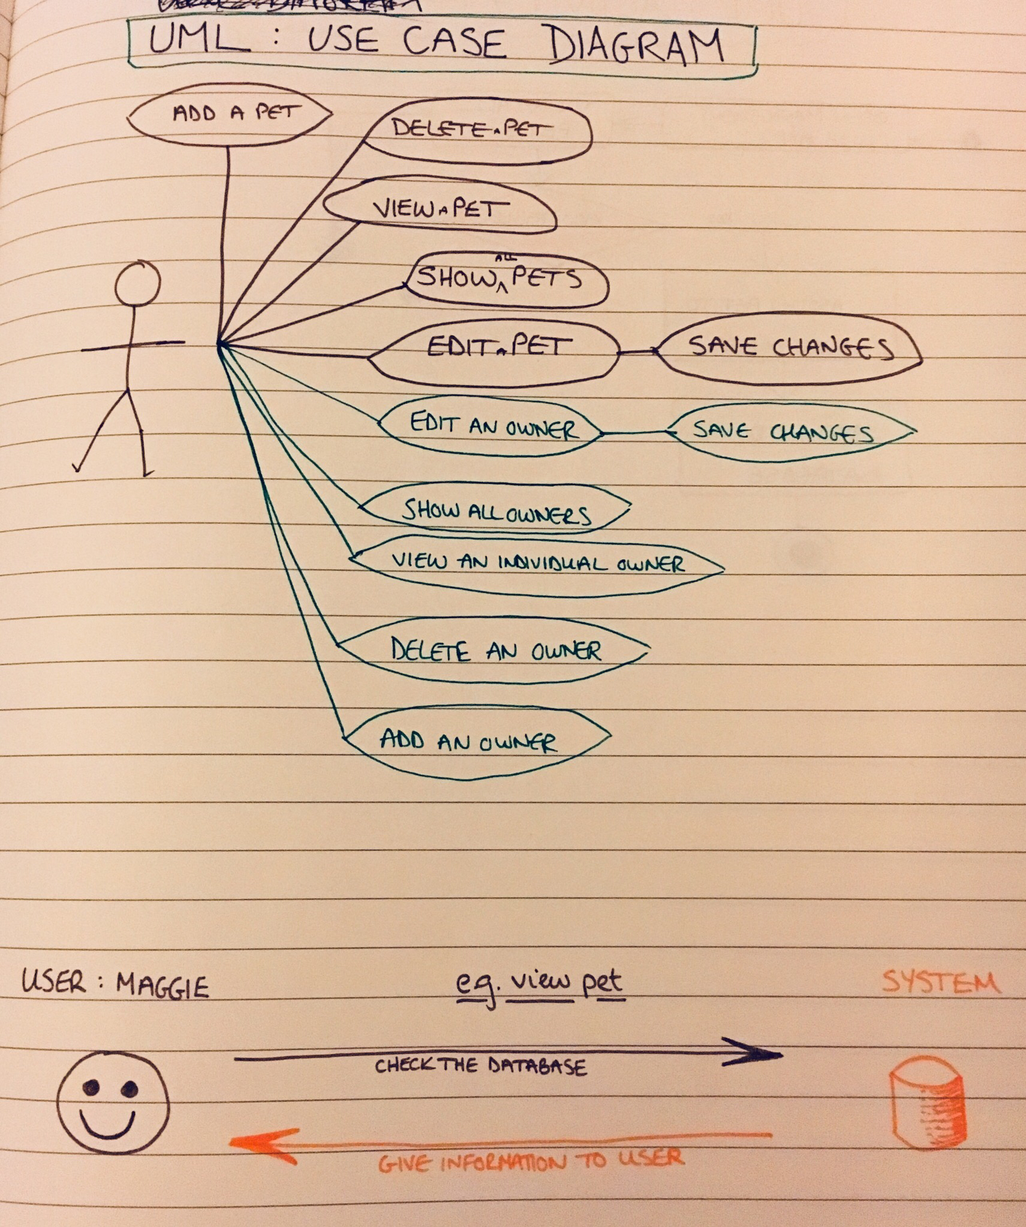

**A.D.2 Class diagram**

Evidence for unit , example from homework (hotel room)

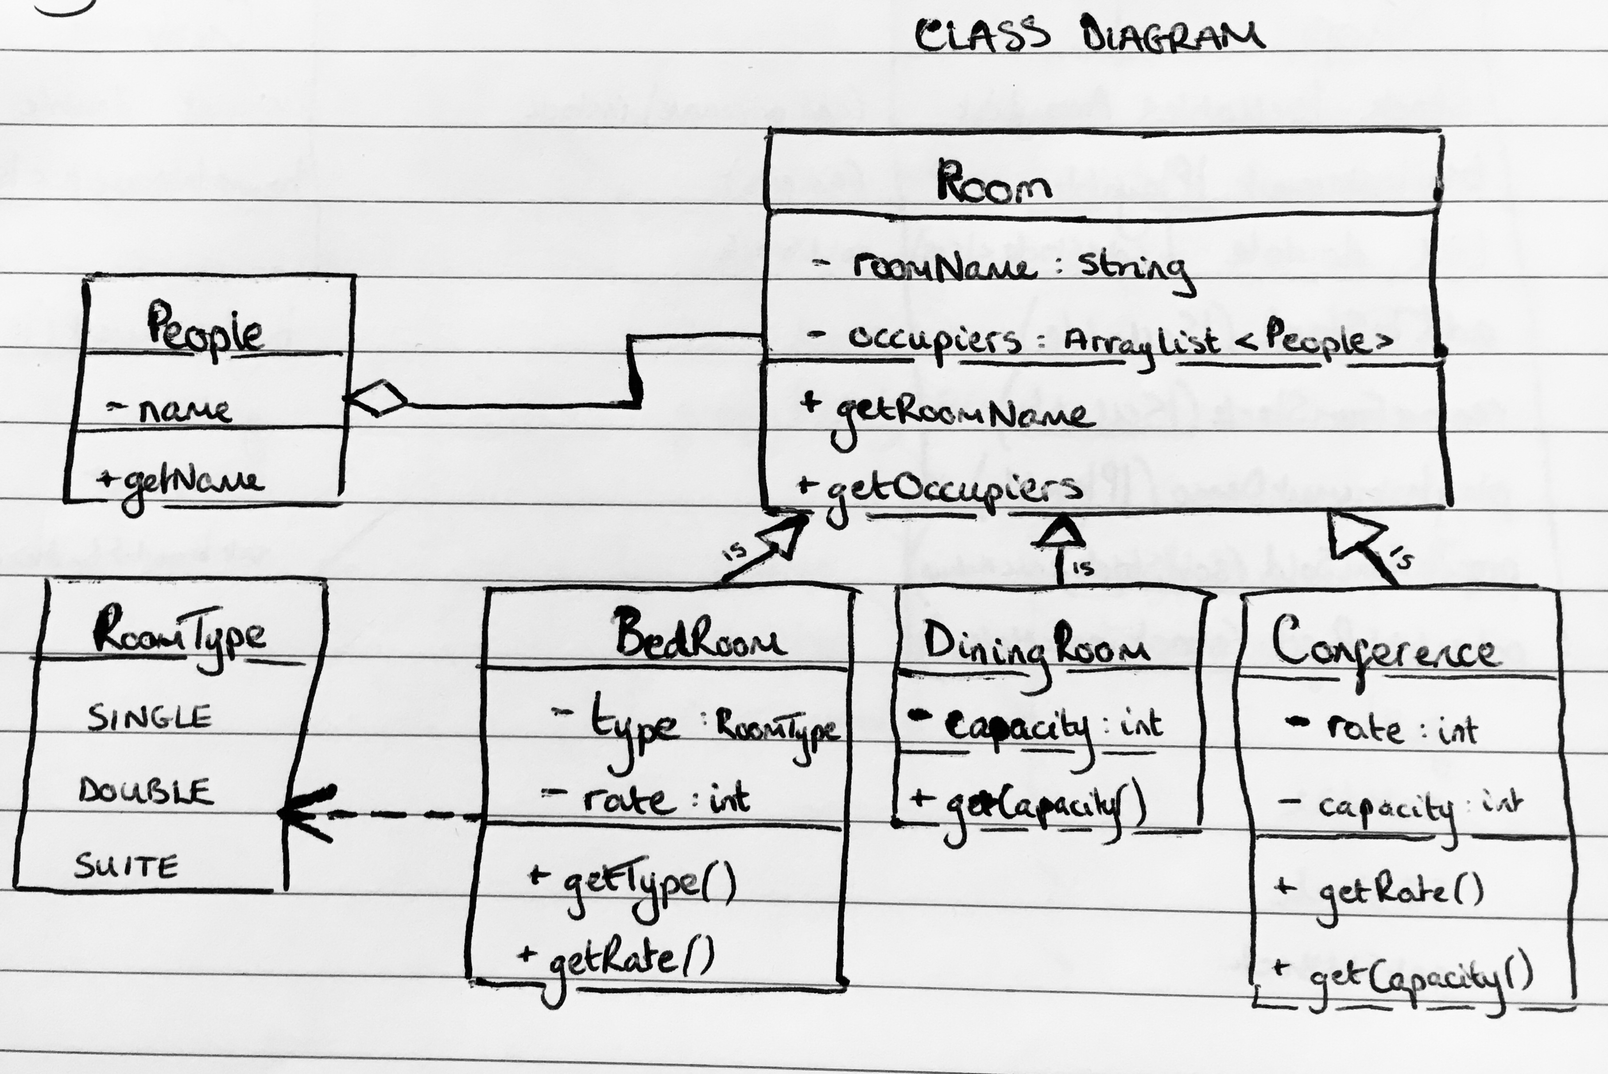

­­­

**A.D.3 Object diagram**

Evidence for unit, from Ruby individual project (pet shop)

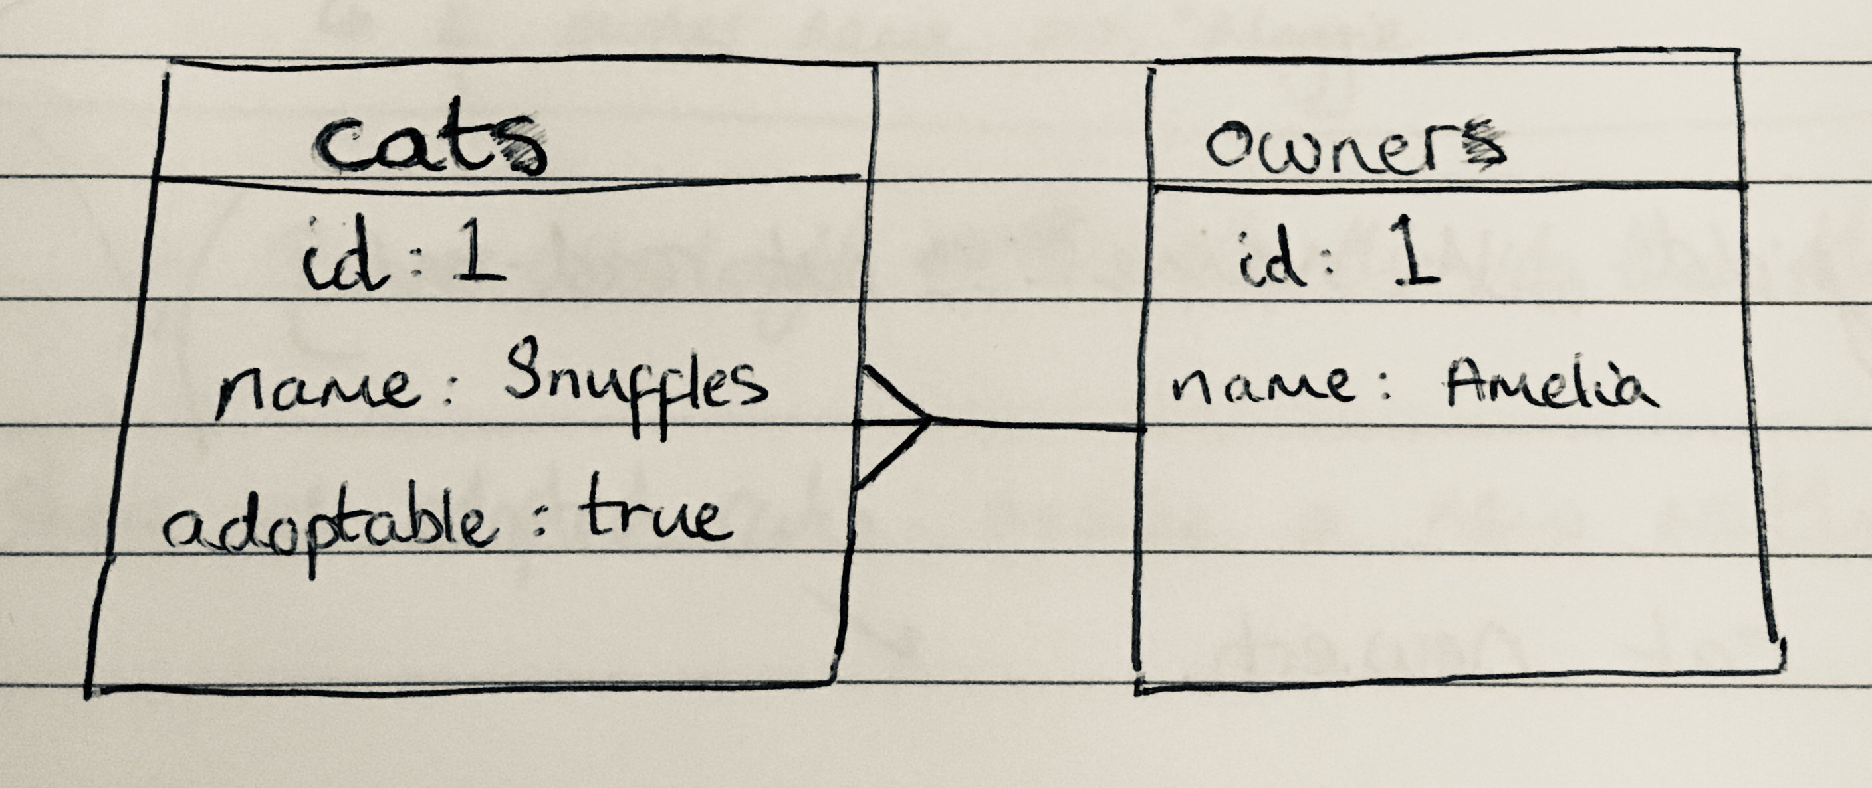

**A.D.4 Activity diagram**

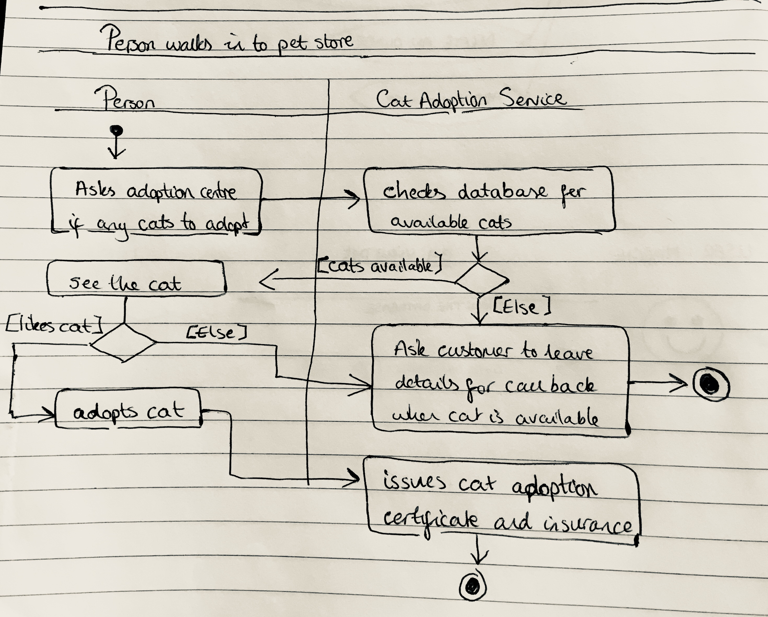

**A.D.5 Inheritance diagram**

Bedroom, DiningRoom and Conference inherit from the superclass Room

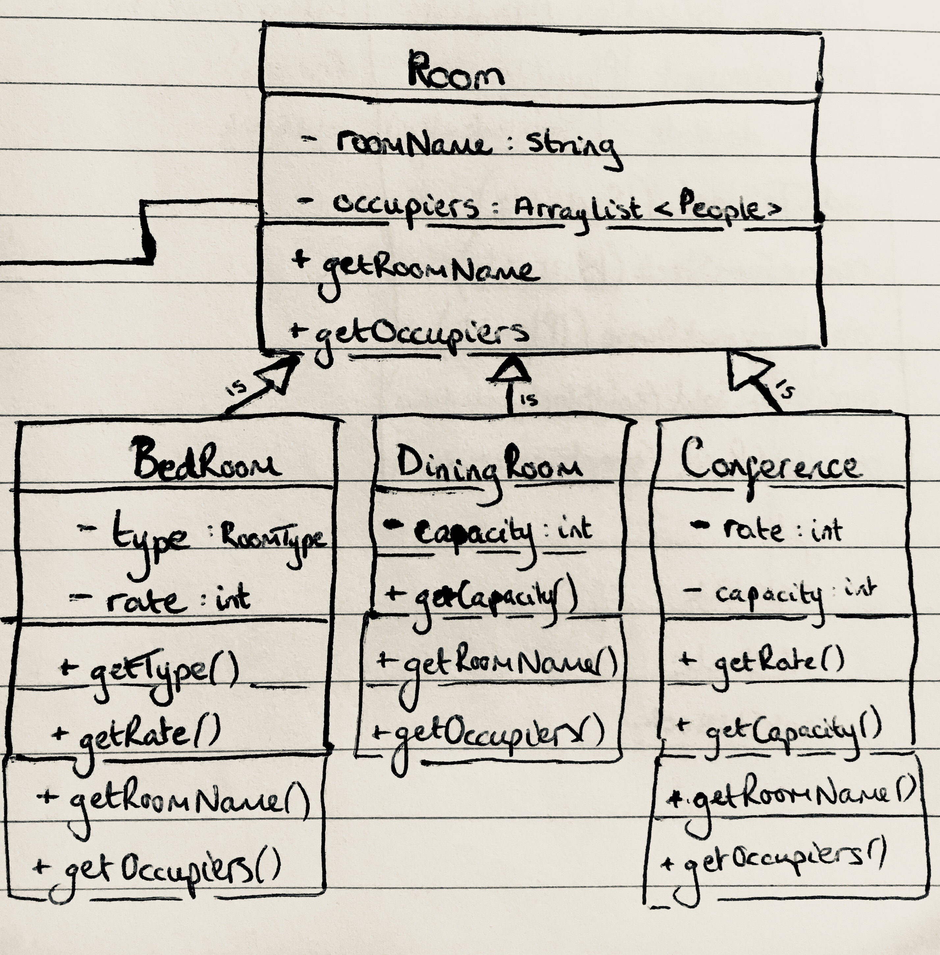

**A.D.6 Implementations Constraints**

|  |  |  |
| --- | --- | --- |
| **TOPIC** | **POSSIBLE EFFECT OF CONSTRAINT ON PRODUCT** | **SOLUTION** |
| **Hardware and software platforms** | Application is limited to only being accessible when the device used is connected to the internet. This would constrain the user to only using it when on the internet, limiting their ability to update the database from anywhere. | Make a locally hosted version for the user which syncs with the internet hosted one when internet becomes available |
| **Performance requirements** | Heroku is being used to host the web app. Heroku however is not the most powerful nor fastest hosting tool available, which could make the performance of the app run lower than usual. | As it is a small application, it is unlikely that the limitations of Heroku will have an effect on the performance of the app. |
| **Persistent storage and transactions** | If data is not stored to a database, data could be lost or may not load. | Make database available by storing on Heroku, no loss of data that way. |
| **Usability** | If the interface is not clear, data cannot be entered or returned: user frustration. | Allow for smooth user interface: explain how the web app is designed to be used. |
| **Budgets** | If there is no budget or means to host a website or remote server, the web app can not be used | Host web app on a free web hosting app such as Heroku. |
| **Time limitations** | Work has to be done in a week: website design may not be completed in time. | Work efficiently and plan each task as sprints to ensure the MVP is achieved. |